Frontier Detection in Autonomous Drone Exploration Using a Hybrid of Frontier-Tracing and Ray-Casting Algorithms
Sugiarto Cokrowibowo^{1,2}, Rustan Tarakka¹ and Andi Amijoyo Mochtar^{1*}
¹ Department of Mechanical Engineering, Universitas Hasanuddin, Makassar, Indonesia
² Department of Informatics, Universitas Sulawesi Barat, Majene, Indonesia

*E-mail: andijoyo@unhas.ac.id

Abstract. Frontier-based exploration has emerged as a fundamental strategy in robotic navigation, where frontier cells define the boundary between known and unknown regions of an environment. This approach involves iteratively detecting and traversing frontiers until no unexplored areas remain, with overall efficiency strongly influenced by the speed and accuracy of frontier detection. In this paper, we present a frontier detection method for autonomous drone exploration that combines the Frontier-Tracing Frontier Detection (FTFD) algorithm with a ray-casting approach. The proposed method exploits previously identified frontiers and scan endpoints to determine new frontiers while employing ray casting to detect exploration boundaries in the immediate surroundings of the drone. This integration is particularly effective for drones equipped with environmental sensors mounted on four sides of the platform, enabling full 360-degree coverage of the exploration space.
1. Introduction
Unmanned Aerial Vehicle (UAV), often referred to as a drone, is an aircraft that operates without an onboard pilot. These vehicles can be controlled remotely [1]. UAVs are aerial systems capable of carrying out various tasks without direct human involvement. They are often managed remotely using electronic devices like sensors and microcontrollers. UAVs are particularly useful for autonomous operations in environments that pose risks to human safety [2]. UAV capable of performing various tasks autonomously, especially in hazardous environments.
The concept of frontiers was originally formulated by Brian Yamauchi [3][4]. since their introduction, frontiers have been widely adopted in various robotic exploration strategies, both for single-robot systems and multi-robot teams [5][6][7][8]. Frontier detection is a critical element of exploration algorithms, where improvements in its efficiency directly accelerate the exploration process. Faster detection not only reduces overall exploration time but also enhances decision-making by utilizing more recent sensor data. As modern sensors provide increasingly rapid inputs, frontier detection has emerged as the primary bottleneck in robotic exploration, underscoring the need for more efficient detection strategies.
Maps in robotic exploration are commonly represented as occupancy grids or connected regions, where each cell corresponds to a physical location in space. A cell may exist in one of several states: unknown (the presence of an obstacle is uncertain), freespace (no obstacle is present and the cell is traversable), or occupied (an obstacle is present). For simplicity, this paper refers to known freespace and known occupied as freespace and occupied, respectively. These states are typically encoded as probabilistic values between 0 and 1, indicating the likelihood of obstacle presence. Within this representation, frontiers are defined as freespace cells that share at least one neighbor cell in an unknown state [3][4].
2. Related Works
Several methods have been proposed for frontier detection in robotic exploration. The most basic approach, known as the Naïve method, evaluates every cell in the occupancy grid to determine whether it represents freespace with at least one adjacent unknown cell. To improve efficiency, a number of more advanced algorithms have been introduced. These include the Wavefront Frontier Detector (WFD), Fast Frontier Detection (FFD), and their incremental and parallel variants (WFD-INC and WFD-IP). The Naïve Active Area (NaïveAA) algorithm further enhances performance by achieving frontier detection in constant time, restricting evaluations to active areas defined by sensor scans. More recent approaches, such as the Expanding-Wavefront Frontier Detection (EWFD) and the Frontier-Tracing Frontier Detection (FTFD), leverage temporal information: EWFD utilizes previously identified frontiers as starting points for detecting new ones in unexplored regions, while FTFD combines past frontiers with scan endpoints to determine frontiers at the current timestep [9][10][11][12][5]. This paper presents a frontier detection method for autonomous drone exploration that integrates the Frontier-Tracing Frontier Detection (FTFD) algorithm with a ray-casting approach.
3. Proposed Method
Let the set of all cells in the drone’s map be denoted as M, with its cardinality represented by |M|. After the environment has been fully explored, the subset of cells classified as free space is defined as M_free. Each cell in the map can exist in one of three possible states: unknown, free space, or occupied by an obstacle. At a given time step t, the set of cells identified as free space is denoted as P_t_free. Correspondingly, the set of cells recognized as obstacles is represented by P_t_obs, while the set of cells remaining unexplored or unknown is denoted as P_t_unk. Let O_t denote the sensor observation at time t, and let S(O_t) represent the set of cells encompassed (i.e., visible) by this observation. The corresponding active area at time t is denoted as A_t. This active area provides a computationally convenient over-approximation of the region covered by the sensor’s field of view. A common formulation defines it as the axis-aligned bounding box that minimally encloses both the origin of the sensor observation and the endpoints of the sensor rays. The maximum number of cells that can be observed in a single sensor measurement is denoted as S_max. Accordingly, the upper bound on the size of the active area is represented by A_max, with the constraint that S(O_t) ≤ S_max ≤ A_max. A cell is defined as a neighbor of another cell if it lies in direct adjacency, such that the two cells share either a common edge or a common vertex. The set of frontier cells identified at time t is denoted as F_t.
The Frontier-Tracing Frontier Detection (FTFD) algorithm exploits the fact that the perimeter of a new sensor observation is highly likely to intersect with previously identified frontiers. Frontier cells within the observed region, together with the endpoints of the sensor rays, serve as initial candidates for tracing new frontiers along the boundary of the observation. Specifically, at each time step t, a new observation O_t is obtained and the drone’s environmental map is updated. The corresponding frontier set F_t-1 is then revised by incorporating the newly acquired information from O_t, resulting in an updated frontier set F_t.

To implement Frontier Detection in Autonomous Drone Exploration Using a Hybrid of Frontier-Tracing and Ray-Casting Algorithms, a drone equipped with four ranging sensors oriented forward, backward, left, and right is utilized, as illustrated in Figure 1.
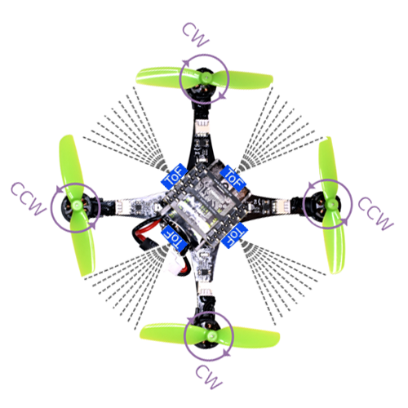
Figure 1 Representation of four ranging sensors facing forward, backward, left, and right on a drone

The following presents the proposed integration of the Frontier-Tracing Frontier Detection (FTFD) algorithm with the ray-casting algorithm:

Algorithm DetectFrontiers(droneIndex, ci, cj)
Input: droneIndex, current cell (ci, cj)
Output: Updated frontier set frontiers[droneIndex]

1: Initialize parameters: rays = 360, step = 0.01, MAX_RADIUS = sensorFoV * cellSize + cellSize
2: For each ray direction i from 0 to 360 with step 2:
3: Compute ray direction (dx, dy) from angle i
4: Start ray from the center of cell (ci, cj)
5: While ray length < MAX_RADIUS:
6: Move ray forward by step
7: Convert ray position to grid cell (row, col)
8: If cell is outside map OR is obstacle/wall:
9: If cell is valid and marked unknown:
10: Mark (row, col) as frontier and update frontier
11: Stop tracing this ray
12: End While
13: End For
14: Return frontiers[droneIndex]

Frontier detection is performed through a ray-casting algorithm that utilizes distance measurements from four ranging sensors positioned in the forward, backward, left, and right orientations. The newly identified frontiers are subsequently integrated into the existing frontier set managed by the Frontier-Tracing Frontier Detection (FTFD) algorithm. The drone then proceeds to the closest frontier by employing a shortest-path strategy, in which Breadth-First Search (BFS) is adopted as a standard approach in frontier-based exploration. Upon reaching the selected frontier, it is removed from the frontier set, while the remaining unexplored frontiers are retained as potential navigation targets.
Step-by-Step Workflow for frontier detection in autonomous drone exploration using a hybrid of frontier-tracing and ray-casting algorithms:
- Frontier Detection: Frontiers are identified using a ray-casting algorithm, which leverages distance measurements obtained from four ranging sensors mounted on the drone and oriented in the forward, backward, left, and right directions.
- Frontier Set Update: The newly detected frontiers are integrated into the existing frontier set maintained by the Frontier-Tracing Frontier Detection (FTFD) algorithm. This ensures that the collection of frontiers dynamically reflects the most recent sensor observations.
- Frontier Selection and Navigation: The drone selects the nearest frontier and plans its movement using the shortest-path algorithm. In this implementation, Breadth-First Search (BFS) is employed, as it is a widely adopted approach in frontier-based exploration.
- Frontier Management: Once the nearest frontier has been successfully reached, it is removed from the frontier set. Other frontiers that remain unexplored are preserved in the collection, providing subsequent navigation goals for the drone.

Figure 2 presents the results of frontier detection obtained through the ray-casting algorithm.

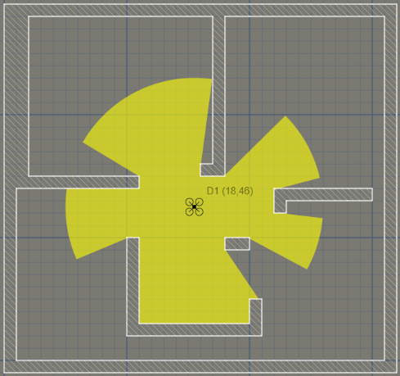
Figure 2 Frontier Detection using Ray-Casting Algorithm
4. Simulation
The simulation of Frontier Detection in Autonomous Drone Exploration Using a Hybrid of Frontier-Tracing and Ray-Casting Algorithms is implemented using the JavaFX framework. The environment is modeled as a grid-based occupancy map with a cell size of 10 pixels, resulting in a workspace of 50 × 50 grid cells. The drone is equipped with a simulated sensor modeled using the ray-casting algorithm, providing a 360° field of view with a maximum sensing radius of 10 cells. Within this environment, walls and static obstacles are introduced to define navigable and restricted areas. The exploration process is carried out by iteratively detecting frontiers and navigating toward them, with the visualization highlighting the sensor coverage, detected frontiers, and the drone’s exploration path. This configuration enables a systematic evaluation of the proposed hybrid frontier detection method under controlled spatial and sensing parameters.
5. Result
The result as illustrated in Figure 2 was successfully conducted using the JavaFX framework within a workspace of 100 × 100 grid cells, with the drone equipped with a sensor field of view of 10 cells. The results demonstrate the effective updating of frontiers through the application of the Frontier-Tracing Frontier Detection (FTFD) algorithm, while the ray-casting algorithm accurately captured the drone’s surrounding environment. The integration of both methods enabled the visualization of dynamic frontier updates in parallel with real-time environmental sensing, validating the suitability of the proposed hybrid approach for autonomous exploration tasks.
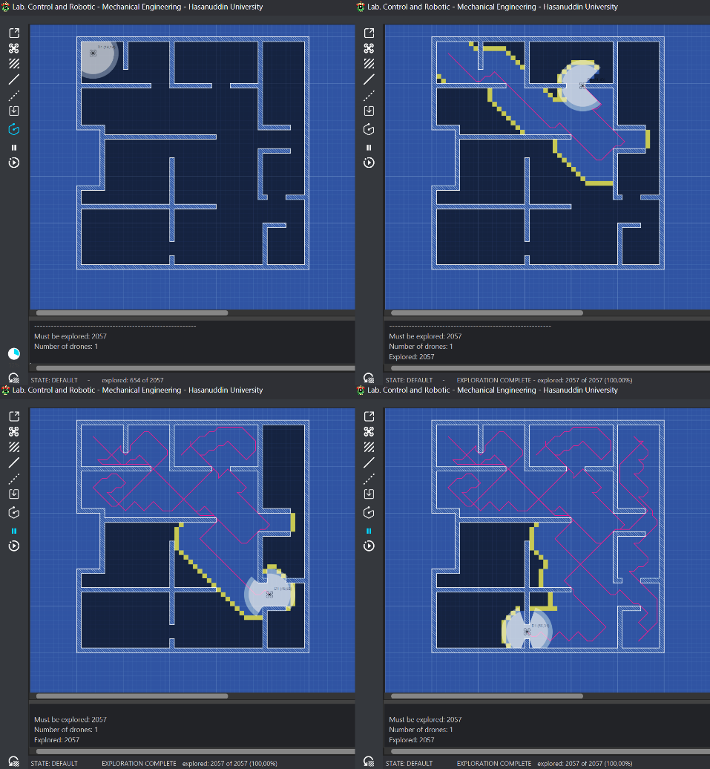
Figure 3 Simulation of Frontier Detection in Autonomous Drone Exploration Using a Hybrid of Frontier-Tracing and Ray-Casting Algorithms is implemented using the JavaFX framework
The final result of the exploration in Frontier Detection in Autonomous Drone Exploration Using a Hybrid of Frontier-Tracing and Ray-Casting Algorithms, implemented using the JavaFX framework, demonstrates that all 2057 cells in the environment designated for exploration were successfully explored as illustrated in Figure 3.

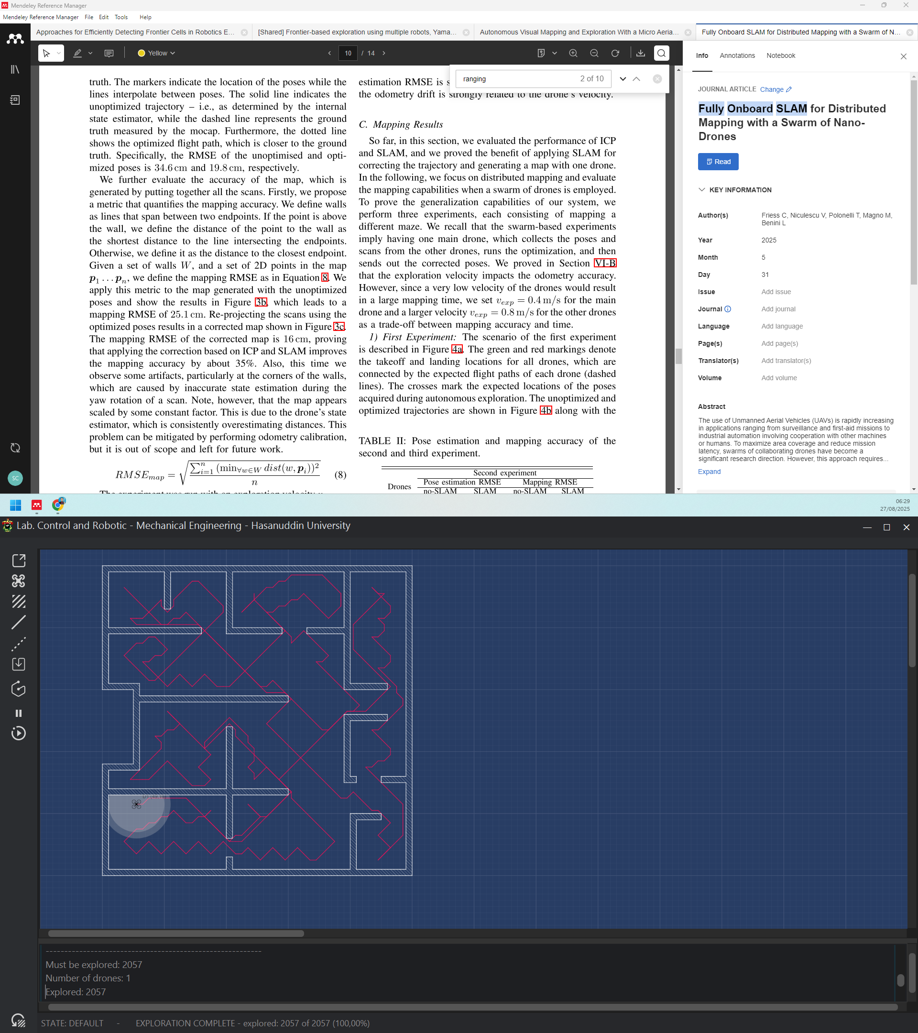
Figure 4 Final result of the exploration

6. Conclusion
This paper has presented an approach to Frontier Detection in Autonomous Drone Exploration Using a Hybrid of Frontier-Tracing and Ray-Casting Algorithms, implemented within the JavaFX framework. The ray-casting algorithm was adopted as it aligns with the sensing configuration of drones equipped with four range sensors oriented in the forward, backward, left, and right directions, thereby providing effective environmental perception. To enhance the efficiency of frontier detection, the strategy of memoization was integrated into the Frontier-Tracing Frontier Detection (FTFD) algorithm. The FTFD method leverages the observation that the perimeter of new sensor data is highly likely to intersect with previously identified frontiers, enabling more efficient frontier updates. Simulation results demonstrated that the proposed hybrid approach successfully achieved complete exploration of the grid-based environment, validating its effectiveness for autonomous drone exploration tasks. For future research, we intend to extend the proposed frontier-based exploration algorithm to a swarm of drones, enabling cooperative exploration in larger and more complex environments. To facilitate decentralized coordination among the swarm, we plan to adopt a stigmergy-based mechanism utilizing digital pheromones as an indirect communication strategy. This approach is expected to enhance scalability, robustness, and efficiency in multi-drone exploration tasks by allowing agents to exchange information through the environment rather than relying solely on direct communication.
References
[1] A. Hemmati, M. Zarei, and A. Souri, “UAV-based Internet of Vehicles: A systematic literature review,” May 01, 2023, Elsevier B.V. doi: 10.1016/j.iswa.2023.200226.
[2] S. A. H. Mohsan, N. Q. H. Othman, Y. Li, M. H. Alsharif, and M. A. Khan, “Unmanned aerial vehicles (UAVs): practical aspects, applications, open challenges, security issues, and future trends,” Mar. 01, 2023, Springer Science and Business Media Deutschland GmbH. doi: 10.1007/s11370-022-00452-4.
[3] B. Yamauchi, “A frontier-based exploration for autonomous exploration,” IEEE International Symposium on Computational Intelligence in Robotics and Automation, Monterey, CA, pp. 146–151, 1997, [Online]. Available: https://pdfs.semanticscholar.org/9afb/8b6ee449e1ddf1268ace8efb4b69578b94f6.pdf
[4] B. Yamauchi, “Frontier-based exploration using multiple robots,” Proceedings of the International Conference on Autonomous Agents, pp. 47–53, 1998, doi: 10.1145/280765.280773.
[5] P. Quin, D. D. K. Nguyen, T. L. Vu, A. Alempijevic, and G. Paul, “Approaches for Efficiently Detecting Frontier Cells in Robotics Exploration,” Front Robot AI, vol. 8, no. February, pp. 1–15, 2021, doi: 10.3389/frobt.2021.616470.
[6] B. Fang, J. Ding, and Z. Wang, “Autonomous Robotic Exploration Based on Frontier Point Optimization and Multistep Path Planning,” IEEE Access, vol. 7, pp. 46104–46113, 2019, doi: 10.1109/ACCESS.2019.2909307.
[7] Q. Tang, Z. Xu, F. Yu, Z. Zhang, and J. Zhang, “Dynamic target searching and tracking with swarm robots based on stigmergy mechanism,” Rob Auton Syst, vol. 120, p. 103251, 2019, doi: 10.1016/j.robot.2019.103251.
[8] C. Dornhege and A. Kleiner, “A frontier-void-based approach for autonomous exploration in 3d,” 9th IEEE International Symposium on Safety, Security, and Rescue Robotics, SSRR 2011, no. November 2011, pp. 351–356, 2011, doi: 10.1109/SSRR.2011.6106778.
[9] A. Batinovic, J. Oršulic, T. Petrovic, and S. Bogdan, “Decentralized strategy for cooperative multi-robot exploration and mapping,” IFAC-PapersOnLine, vol. 53, pp. 9682–9687, 2020, doi: 10.1016/j.ifacol.2020.12.2618.
[10] A. Batinovic, T. Petrovic, A. Ivanovic, F. Petric, and S. Bogdan, “A Multi-Resolution Frontier-Based Planner for Autonomous 3D Exploration,” IEEE Robot Autom Lett, vol. 6, no. 3, pp. 4528–4535, 2021, doi: 10.1109/LRA.2021.3068923.
[11] A. Dai, S. Papatheodorou, N. Funk, D. Tzoumanikas, and S. Leutenegger, “Fast Frontier-based Information-driven Autonomous Exploration with an MAV,” Proc IEEE Int Conf Robot Autom, pp. 9570–9576, 2020, doi: 10.1109/ICRA40945.2020.9196707.
[12] M. Keidar and G. A. Kaminka, “Robot exploration with fast frontier detection: Theory and experiments,” 11th International Conference on Autonomous Agents and Multiagent Systems 2012, AAMAS 2012: Innovative Applications Track, vol. 1, pp. 480–487, 2012.

